Final Project Consulting Report
Proposal for Canadian AI Innovation Strategy

MIE1624H
Group 10

Daniel Rafique 1006112671
Connor Ludwig
Joshua Sit 1011863468
Bjoern Greiner-Perth 1012881801
Xingda Jiang 1007170525
Pei Yi Kuan

November 30, 2025

1.0 Introduction
This report provides a strategic proposal for the Government of Canada’s next AI strategy, regarding the future development of Artificial Intelligence (AI). The objective is to define a comprehensive plan that allows Canada to transition from a research hub into a global leader in AI innovation and business application. The problem we aim to solve is analyzing which key factors contribute most to AI competitiveness and how these can be used to improve Canada’s role in global AI leadership. The focus remains on updating the national approach to ensure long-term prosperity and economic security.

Artificial Intelligence has evolved from an experimental technology into a fundamental driver of the global economy. It is currently transforming critical sectors such as healthcare, finance, and manufacturing by automating complex tasks and creating new business value. As the market for these technologies grows at a rapid pace, countries around the world are competing to capture the resulting economic benefits. Adapting to these market changes and leveraging existing strengths is essential for success in this new era of innovation. Canada possesses a strong foundation to build upon. In 2017, the federal government launched the first phase of the Pan-Canadian Artificial Intelligence Strategy under the leadership of the Canadian Institute for Advanced Research (CIFAR) [1]. This initiative successfully achieved its primary goals of attracting skilled talent and establishing Canada as a centre for academic research. However, the global landscape has shifted significantly since that time. While Canada focused on research and talent, other nations prioritized the commercial application of these technologies and the construction of large-scale physical infrastructure.

The priority now is to improve Canada's AI competitiveness, measuring how effectively a nation can use AI to generate economic growth and maintain influence. Currently, Canada ranks well in talent and ethical governance but trails leading nations like the United States and China in commercialization and infrastructure availability. These gaps lower the national standing on global benchmarks such as the Tortoise Global AI Index. Improving this position is necessary to ensure domestic businesses remain productive and competitive. The proposed policies aim to close the gap between research output and industrial adoption, ensuring Canada creates a complete and resilient AI ecosystem.

2.0 Factors that contribute to AI competitiveness across the world
To improve Canada’s global competitiveness, we first need to understand what drives success in the international AI market. We used LLMs to process and analyze national strategy documents, government agendas, and CIFAR reports, to extract meaningful factors that global leaders prioritize and compare them to Canada’s current focus. We further used regression models on datasets from OECD and Kaggle to find statistical evidence for which factors most strongly correlate with a high national AI score.

2.1 Analyzing International AI Index Scoring
It is important to first understand how each country scores their AI competitiveness and which factors are considered important for advancing AI influence. This provides us with valuable information on areas Canada should focus on to position itself better with reference to other countries. The ground truth for comparing AI competitiveness is the widely adopted tortoise global AI index [ref] which includes 3 main pillars split across 7 sub pillars. These include, talent, infrastructure, operating environment, research, development, government strategy, and commercial pillars. The data collected for this analysis included various national agendas and strategic policy documents for a small set of countries and continents. Using an OpenAPI client with GPT-5-mini, we summarized how each country evaluates its AI innovation and competitiveness, highlighting their key indicators, priority investment areas, perceived position in the global AI landscape, and an inferred competitiveness score based on the extracted data (see Appendix for extracted summaries).

Based on this analysis, some key factors contributing AI innovation for the United States (top ranked on AI index) include compute and data infrastructure, supply chain resilience for semi-conductor manufacturing, energy and grid capacity for AI workloads, controlling new AI paradigms, retaining top talent, and ensuring they have diverse technological partnerships. Their priority investment areas include national compute access and NAIRR cloud compute for researchers, building domestic data centers, expanding semiconductor manufacturing, and improving AI education and talent through apprenticeships, and internship programs. Overall the US approach is a very infrastructure and talent based approach.

Conversely looking at China’s AI innovation strategies, they prioritize research output through high volumes of publications, improving talent pools through university educational pipelines, and creating nationalized data governance by providing researchers with high quality large scale datasets. Their investment priorities include data center infrastructure, talent development, and an increased focus on robotic based AI developments. China and US based strategies contrast more heavily with lower indexed regions like Africa, whose strategy is largely focused on reskilling their population to adopt AI, investing in start-ups, and catching up on infrastructure gaps.

Finally, the Canadian strategic scene is positioned in the middle, having a significant advantage over many countries in terms of talent and infrastructure, but still behind top countries like China and the US. From the current strategic data, Canada focuses on research output, maintaining world class academic institutions and partnerships such as Vector and Mila, and foreign investments for commercialization and start-up activity. The notable investment areas include national high performance computer infrastructure, scaling commercialization and patents, improving talent pipelines, and focusing on AI governance standards and ethics. The latter areas of research and AI safety is where Canada acts as a global leader with room to expand their influence through improved commercialization and infrastructure.

2.2 Kaggle Dataset Regression Analysis
Tortoise Media publishes an AI index ranking of nations based on 7 different pillars and additionally scores the scale and intensity of the country’s AI economy. Understanding what drives a country to achieve high scores overall and in each pillar is key to developing a data-based AI strategy. To determine the underlying features driving each pillar of AI performance, we used Stanford data [ref] containing 30 training features for each country. This data was used to train a linear regression model to predict the overall AI index score of a country, an additional regression model was trained for each of the pillars contributing to the AI index score. To determine the importance of a particular feature to the AI index score, the corresponding weight in the regression model was analyzed to find if it had a significant positive or negative impact. Bar graphs visualizing the weights of each regression model for the overall index score, the 7 pillars, and the intensity and scale score are included in the index in figures 1-10.

The results obtained from our linear regression model do not yield a comprehensive policy plan, but the results do give an indication of where to dig deeper and can provide numerical backing for more qualitative plans. The features positively correlated to the overall index score, and any pillars that Canada scored poorly in were identified as key areas of focus. Additionally, several features were negatively correlated to many desired areas of improvement; these were identified as areas that our policy should seek to invest fewer resources in, to avoid regressing in our AI index score.

2.3 Canadian Institute for Advanced Research Sentiment Analysis
The Canadian institute for Advanced Research (CIFAR) is one of the world's leading organizations in mobilizing skilled talent in the pursuit of cutting edge AI research. Using their large archive of articles, strategic policies, and interviews on the various topics on AI, we conducted an analysis on the major driving forces for the advancement of Canadian innovation in the AI space. We utilized a GPT-5-mini via an open API client to break down competitive factors by each major pillar of innovation in the global AI index. Within each major pillar, we’ve summarized what the CIFAR articles had to say regarding the major factors that could allow Canada to stay competitive, the proposed strategies across the articles, Canada’s current gaps and weaknesses, and our current strengths. Table X in the appendix summarizes some of the insights drawn from the CIFAR content from the LLMs with corresponding prompts in the provided notebook.

CIFAR’s body of work highlights that Canada’s AI competitiveness is anchored by world-class research institutions and strong ethical governance foundations, but is increasingly constrained by infrastructure, commercialization, and talent-retention gaps. Across strategy briefs and sector reports, CIFAR emphasizes the need for scalable compute capacity, standardized data infrastructure, long-horizon research funding, and stronger industry adoption, especially among SMEs and in high-potential sectors like health. While Canada excels in foundational research and collaborative networks, it risks falling behind peers without accelerated investment in distributed compute, applied AI development, commercialization pathways, and more agile regulatory frameworks.
2.4 National Policy Comparative Sentiment Analysis
Next we performed additional sentiment analysis to understand how each country compares with regards to their AI competitiveness as well as which factors contribute to their success. The data collected is the same data used to summarize what each country looks for in positioning themselves in the AI space. These include text based articles and national strategies proposed by and for governments to improve their AI technologies. When looking at Canadian strategic papers and the current Canadian proposal for federal public service in AI innovation, we can see that topics such as government, policy, research, responsibility, talent, trust, and information are some areas that are brought up the most (see figure 1). This is aligned with the CIFAR analysis which positions Canada at the forefront of AI ethics, safety, and research innovation, with a desire to deploy responsible AI.
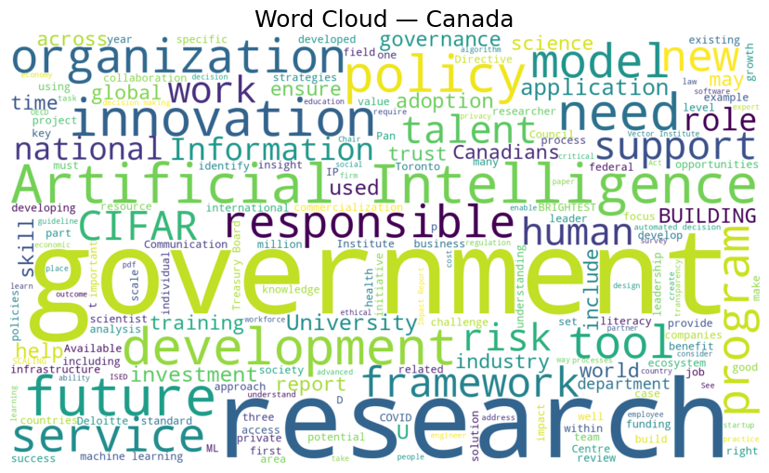
Figure 1: Wordcloud of Canadian Strategic AI articles and government policy documents
Next, we used the gpt-5-mini AI client to rank how much each country’s strategic approach to AI innovation across 6 major pillars to identify which areas Canada might be ahead or behind in. Figure 2 below summarizes the sentiment strength for each pillar, which shows Canada having a relatively low strength in commercialization and infrastructure compared to top countries like China and the US, while being on par with these countries when it comes to research, talent, and safety. This would indicate commercialization and foundational data base building and infrastructure are key areas of improvement and focus within our AI strategy while also maintaining our advantage in the research space. Finally, we also used sentiment analysis to identify which sectors each country’s strategy leaned towards. The following figure 3 shows various sectors and the normalized priorities each country gave to them. Based on the analysis we can see that healthcare is the biggest sector across all countries, followed by manufacturing. Canada seems to only be focused on agriculture, finance, and healthcare without much emphasis on other areas. Diversifying the application of AI across sectors might be identified as an area of improvement compared to countries like Australia, China, and the US which have either more diverse or more heavily weighted sectors for priority.
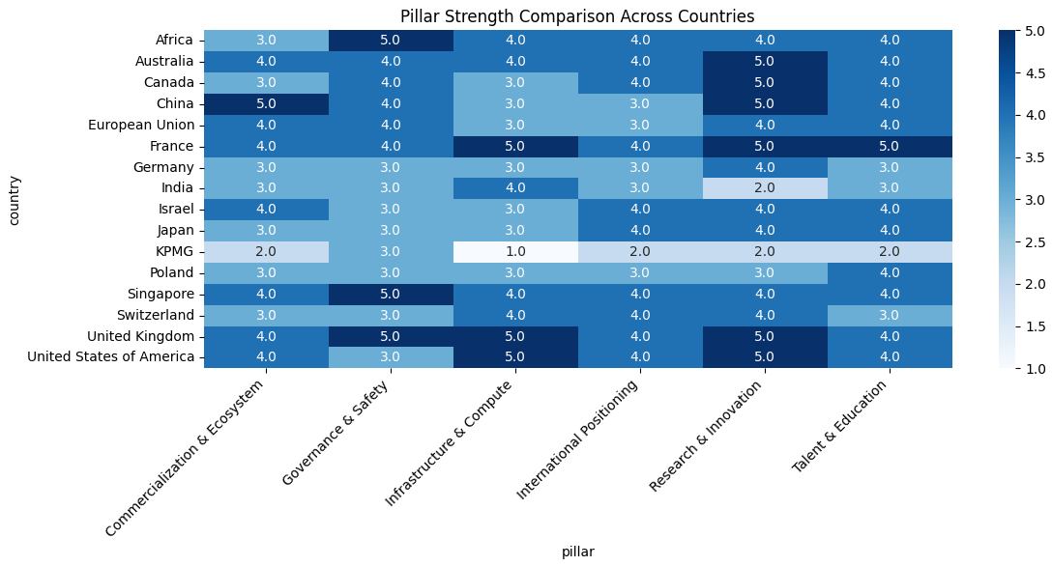
Figure 3: Pillar strength heatmap across countries based on GPT-5-mini sentiment analysis for how much each country prioritize each respective innovation index pillar
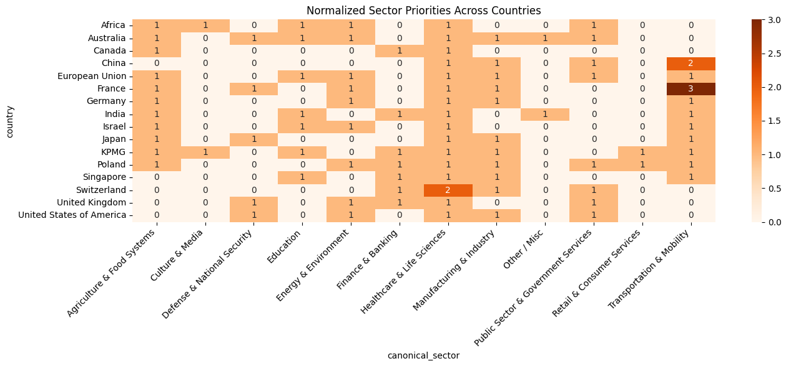Figure 4: Normalized priority heatmap across countries based on GPT-5-mini sentiment analysis for how much each country prioritizes each respective sector
3.0 Proposed Canadian AI Strategy
Canada is at a turning point in its AI trajectory. Our three-stage strategy positions the country to translate its strong research base into broad economic and societal impact. Stage 1 reinforces the talent and education pipeline, expanding advanced research capacity while raising AI literacy across industries. Stage 2 addresses Canada’s most significant weakness by building national data infrastructure and a federated learning ecosystem that enables secure, large-scale model development. Stage 3 converts these capabilities into commercial momentum through targeted incentives, coordinated adoption support, and a modernized IP framework. Together, these steps will strengthen Canada’s position in the Global AI Index and advance the vision of Canada as a leading destination for responsible AI innovation. The following sections will walk through our proposed strategy for Canadian AI innovation.

3.1 Stage 1 - Education focused talent acquisition
Analysis of trends in AI performance through linear regression indicates that AI talent is a driving factor in being a major AI player. Multi-source sentiment analysis indicates that AI talent is a source of strength for Canada, and we aim to maintain and further develop this strength to keep Canada on the cutting edge of AI. The analysis of CIFAR texts and national strategy documents showed that Canada’s AI talent emerges from its AI research institutes and impactful research, but commercial lag in adopting cutting-edge AI technology reduces the AI talent pool in industry.

To maintain the strong AI talent Canada has, while addressing its shortcomings, we propose a 3-pronged approach: (1) Attract top AI academic talent, (2) Invest in AI research, (3) Incentivize AI skill development in the workforce and retain existing AI talent. Below are more detailed steps to address the 3 pillars of our approach:

3.1.1 Attract top AI Academic Talent
Build on the Pan-Canadian AI strategy (2017-2022), this strategy successfully established Canada as a top-tier destination for academic talent. Key initiatives included the Canada CIFAR AI Chairs Program, which recruited and retained over 120 leading researchers at institutes like Mila (Montreal), Vector (Toronto), and Amii (Edmonton). Increasing funding for these institutes and founding new institutes in major metropolitan areas, such as Vancouver, has been successful in the past and will continue to develop Canada as a top-tier destination for academic talent.

3.1.2 Invest in AI Research
Provide funding for applied AI research chairs, splitting development between universities and Canadian enterprises. This, in combination with increased funding for AI institutes, will help invigorate AI research in Canada, pushing us to the forefront of AI research.

3.1.3 Incentivize AI Skill Development
Provide tax credits for companies enrolling in applied AI certification courses to drive mass AI literacy. Direct national AI institutes to support commercial adoption of AI technology to drive job creation in AI-related positions to increase the retention of AI talent, including recent graduates.

We anticipate these 3 areas of focus to drive significant positive results for AI talent in Canada. The substantial focus on research funding to drive Canadian AI talent is supported by our regression analysis; the top positively correlated features to a country’s level of AI talent are its number of conference and journal publications.

3.2 Stage 2 - National Foundational Data and Federated Infrastructure for Canadian AI Competitiveness
Canada’s multi-source sentiment analysis, drawing on CIFAR reports, national strategy documents, and global benchmarking which shows a consistent pattern: Canada excels in AI research, talent development, and responsible governance, but structurally lags in data readiness and foundational infrastructure. Our cross-country analysis (Figure 2) confirms that the U.S. and China maintain a competitive advantage by consolidating large national datasets, enabling high-capacity compute access, and coordinating federal–industry deployment at scale. By contrast, Canada’s fragmented data governance, uneven federated learning capacity, and limited high performance compute infrastructure constrain the translation of strong research into commercial and clinical impact, reinforcing CIFAR’s assessment that infrastructure represents one of the country’s weakest competitive pillars.
To address these gaps, we propose a three-part, sequential strategy centered on (1) a National Closed-Source Data Library, (2) a National Federated Learning Backbone, and (3) sector-specific data standardization starting with healthcare (see figure X). This structure mirrors international best practices observed in the U.S. NIH Data Commons, China’s national industrial data platforms, and the EU’s emerging Data Spaces, while remaining aligned with Canadian privacy values and governance frameworks. This integrated approach directly addresses the weaknesses identified in our sentiment analysis, particularly around infrastructure, compute capacity, and data readiness. By establishing a unified data library, a scalable federated learning network, and a sector-specific health data standardization program, Canada can close the infrastructural gap with global leaders while strengthening its core differentiator: responsible, privacy-preserving AI innovation.
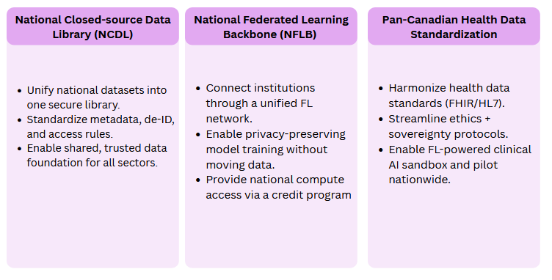
Figure X: high level overview of our proposed Canadian Data infrastructure strategy to take Canada to new heights in large foundational modelling
3.2.1 Establish a National Closed-Source Data Library (NCDL)
The first step is resolving Canada’s cross-institutional data fragmentation. The NCDL would unify high-value datasets such as health, mobility, environment, and industrial telemetry which are under a closed, secure, and access-controlled model. Leveraging existing Trusted Research Environments [2], the NCDL would introduce national metadata schemas, standardized de-identification practices, and harmonized access protocols. Stakeholders include ISED, CIFAR, DRAC, provincial ministries, and Indigenous data governance bodies (OCAP) [3]. Funding requirements can be benchmarked to the Pan-Canadian AI Strategy Phase II allocations [4] to ensure multi-year operability. This platform serves as the foundation upon which all subsequent federated and sector-specific initiatives depend.

3.2.2 Build a National Federated Learning Backbone (NFLB)
Once foundational datasets are consolidated, Canada must enable privacy-preserving model development across provinces and institutions. The NFLB would create a standardized orchestration layer for federated learning (FL), enabling hospitals, universities, and government agencies to train models locally without pooling sensitive data. This backbone would incorporate encryption-at-runtime, differential-privacy-aware training, synthetic data augmentation, audit logging, and bandwidth-optimized multi-site learning workflows. Aligning REB/IRB approvals across institutions would remove a major deployment barrier highlighted in the CIFAR analysis. Funding can operate through a Canadian Compute Credits Program, modeled after global cloud-credit programs, enabling SMEs, researchers, and hospitals to access distributed compute.

3.2.3 Launch a Pan-Canadian Health Data Standardization and AI sandbox initiative
Healthcare emerged as the most consistently prioritized sector in our multi-country analysis (Figure 3). Canada’s strength in health-AI research is undermined by inconsistent provincial EHR formats, slow ethics approvals, and limited interoperability. A National Health AI Sandbox (NHAIS) would harmonize FHIR/HL7-compliant standards, unify REB workflows, implement Indigenous data-sovereignty protocols, and provide FL-enabled clinical model development environments. Pilot deployments in major provinces would validate the model before nationwide expansion.

3.3 Stage 3 - Commercialization Incentives
Stage 3 translates the research, talent, and data infrastructure built in Stages 1 and 2 into tangible economic impact. The pillar heatmap (Figure 3) shows Canada performing strongly on Research & Innovation and Talent & Education but only middling on Commercialization & Ecosystem. Under the current Pan-Canadian AI Strategy and related innovation programs, most federal spending is routed to institutes, chairs, and upstream R&D, with relatively fragmented, grant-based support for IP creation, firm scale-up, and private investment. Stage 3 directly addresses this commercialization gap by rebalancing the existing federal AI envelope toward: (1) a modernized AI IP and patent regime, (2) a coordinated Canadian AI Commercialization and Adoption Center, and (3) targeted incentives for private capital and sector diversification. Rather than relying solely on new taxes or large net-new spending, our approach primarily reallocates a defined share of current AI and innovation budgets toward instruments that translate Stages 1–2 into exportable, Canadian-owned AI products and platforms.

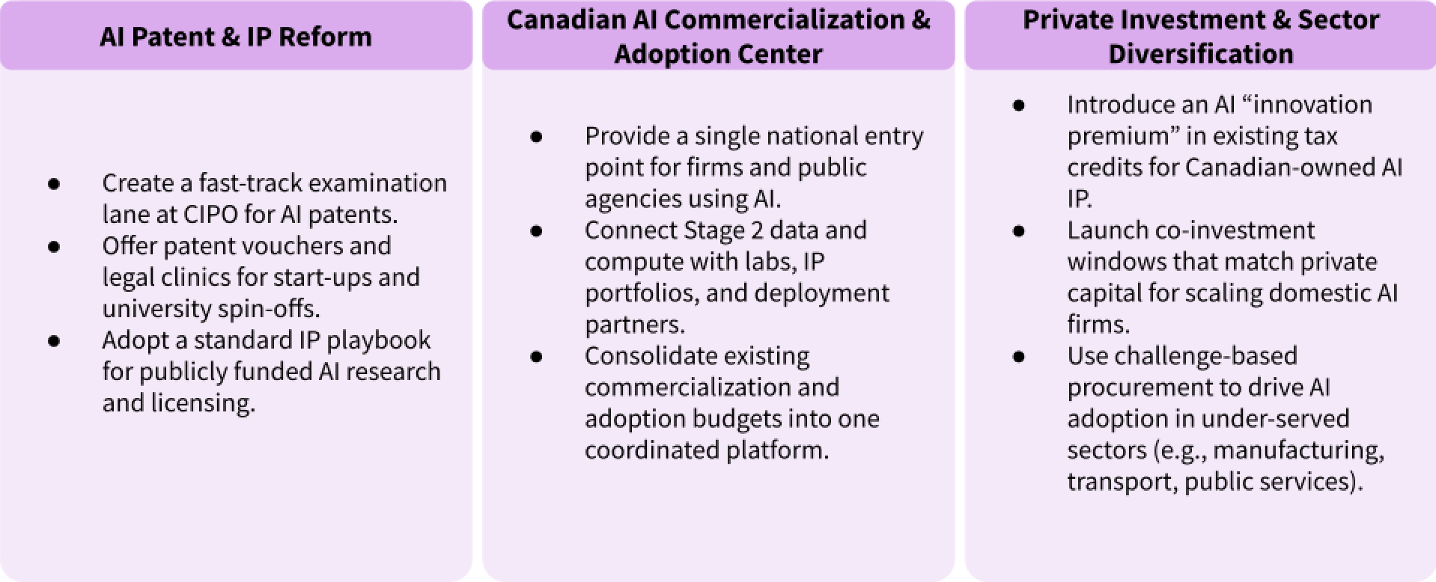
Figure X: high level overview of our proposed Canadian commercialization strategy to translate AI research and data infrastructure into globally competitive Canadian firms
3.3.1 Reform the AI Patent and IP Regime
Currently, AI-related inventions move through the same CIPO processes as all other technologies, facing long examination timelines, standard fee schedules, and limited support for early-stage firms. Within the current AI strategy, only a modest portion of funding is explicitly tied to patenting, licensing, or spin-out formation, which contributes to Canada’s weaker performance on the commercial pillar despite strong upstream research. Drawing on practices in the U.S. and EU, we propose a dedicated AI IP track built around three levers: an accelerated AI patent lane with shorter expected timelines for technically novel, Canadian-developed applications; patent vouchers and legal clinics targeted at first-time AI filers from start-ups and university spin-offs; and a standardized IP playbook for publicly funded AI research that clarifies ownership, revenue sharing, and licensing terms between institutes and private partners. Budget-wise, this regime would repurpose a fixed share of existing AI-strategy and innovation funding—e.g., redirecting a small fraction of generic research grants and broad R&D tax expenditures into outcome-linked IP tools—so that the overall envelope remains similar in size but more explicitly focused on generating Canadian-owned AI patents and licensing revenue.

3.3.2 Establish Canadian AI Commercialization and Adoption Center (CAICC)
Currently, firms and public agencies seeking to apply AI must navigate a fragmented support landscape: each of Mila, Vector, Amii, and CIFAR runs its own industry programs, while federal and provincial adoption schemes are distributed across multiple portals and application processes. This institution-centric model stands in contrast to countries that outperform Canada on commercialization and infrastructure, where central coordination and single “front doors” help move research quickly into pilots and scale-ups. Building on the Stage 2 National Closed-Source Data Library and National Federated Learning Backbone, we propose the creation of a virtual Canadian AI Commercialization and Adoption Center (CAICC) that acts as a unified entry point for companies and public organizations. CAICC would coordinate access to Stage 2 data and compute assets, match firms with relevant research groups and IP portfolios, and host regulatory “sandboxes” for high-impact sectors highlighted in Figure 4 (e.g., healthcare, manufacturing, public sector services). Rather than adding a new layer of programs, CAICC consolidates and re-labels existing commercialization and adoption budgets under a single governance structure, with only a modest additional allocation for shared digital infrastructure and coordination funded from general federal revenues. The net effect is a shift from many small, disconnected initiatives toward a nationally visible platform designed to scale Canadian AI champions.

3.3.3 Incentivize Private Investment and Sector Diversification
Our sentiment and sector analyses show that Canada’s AI strategy is still heavily driven by public funding and research grants, with comparatively weaker tools to mobilize private capital and diversify beyond a narrow set of sectors. In contrast, top performers on the commercialization pillar pair strong public R&D with robust venture ecosystems, mission-oriented procurement, and tax structures that reward IP-rich scale-ups. Stage 3 therefore introduces a focused investment package that changes the composition of Canadian AI spending rather than simply increasing its size. First, we propose an IP-linked “AI innovation premium” within existing tax credit frameworks, offering enhanced relief on profits that can be traced to Canadian-owned AI patents or software, conditional on keeping core R&D and senior technical roles in Canada. Second, we recommend a co-investment window within current federal growth and strategic innovation funds that matches private equity and venture capital for AI firms leveraging Stage 2 infrastructure, with a deliberate focus on later-stage scale-ups in under-served sectors such as manufacturing, transportation, and public services. Third, a small, earmarked portion of existing digital-infrastructure and procurement budgets would be converted into challenge-based AI competitions, where government agencies act as lead customers for solutions to clearly defined problems in priority sectors. Together, these measures redirect part of the present research-heavy envelope toward leveraged private investment and demand-pull instruments, improving Canada’s commercialization and investment pillars while remaining fiscally grounded in existing revenue streams and program architectures.

References
[1] Government of Canada, “Pan-Canadian Artificial Intelligence Strategy,” 2022.
[2] Public Health Agency of Canada, “Trusted Research Environments,” 2023.
[3] First Nations Information Governance Centre, “OCAP Principles,” 2022.
[4] Government of Canada, “Pan-Canadian Artificial Intelligence Strategy — Phase II Budget,” 2022.

Appendix

Table 1 CIFAR article key factors summary extracted via GPT-5-mini
Pillar | Key Competitive Factors | Strategic Priorities Identified | Key Weaknesses / Gaps
Talent | Strong national AI institutes; deep research capacity | Renew and expand AI chairs/fellowships; strengthen early-career and industry-embedded training; widen global recruitment | Retention challenges; uneven geographic representation; limited commercial demand for AI skills
Infrastructure | Secure research environments; early work in federated learning; distributed compute access | Harmonize data/metadata standards; invest in secure sandboxes; expand cloud/GPU availability; support multi-site workflows | High compute costs/bandwidth limits; privacy rules not aligned with federated learning; uneven institutional readiness
Operating Environment | Strong ethics foundations; established REB/IRB processes; emerging Indigenous data governance | Adopt risk-based regulation; streamline ethics/privacy approvals; build technical capacity in oversight bodies | Fragmented, slow privacy processes; low technical literacy in approvals; risk of trust erosion in sensitive sectors
Research | High-impact foundational AI research; strong national coordination | Protect long-horizon fundamental research; expand multidisciplinary networks; increase support for AI safety/alignment | Rising pressure for short-term outputs; limited regional diversity; challenges translating research to deployment
Development | Strength in model development and open-source tooling; sectoral depth (health, climate) | Renew long-term funding for institutes/model programs; co-fund industry–research development; support AI safety efforts | Compute/communication constraints; DP/synthetic data reduce utility; federated deployments complex and expensive
Government Strategy | Established national AI strategy; coordinated institutes; structured funding | Expand commercialization supports; accelerate SME adoption; scale sector-specific deployments | Slow private-sector adoption; uncertainty around sensitive-data use; limited large-scale applied deployments
Commercial | Growing startup ecosystem; SME acceleration; strong health-AI potential | Strengthen commercialization pipelines; expand SME funding; promote open-source deployment frameworks | Weak scale-up capacity; slow adoption; regulatory and trust barriers in high-risk sectors

Figure 1 Linear Regression model weights by feature for predicting Overall AI index score, sorted by absolute value of the coefficient
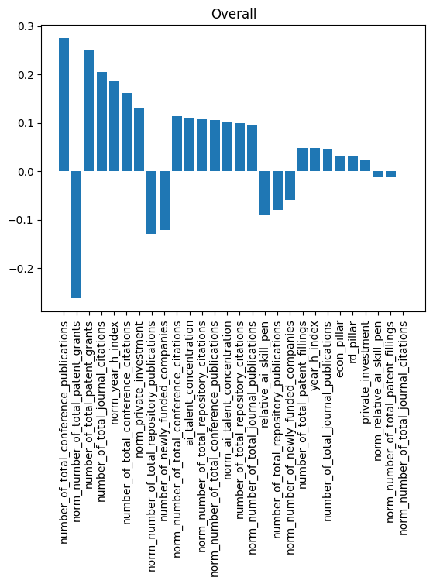

Figure 2 Linear Regression model weights by feature for predicting the Talent AI index score, sorted by absolute value of the coefficient
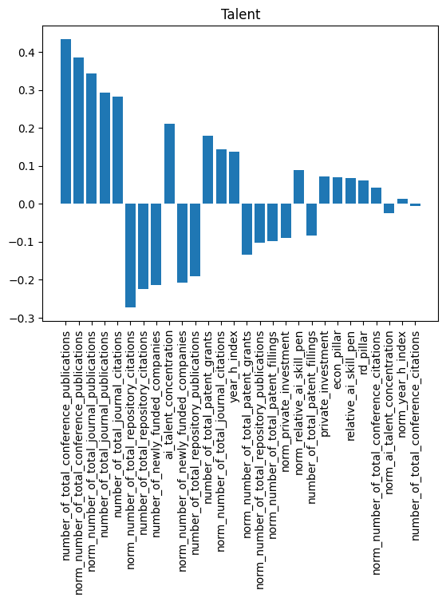

Figure 3 Linear Regression model weights by feature for predicting the Infrastructure AI index score, sorted by absolute value of the coefficient
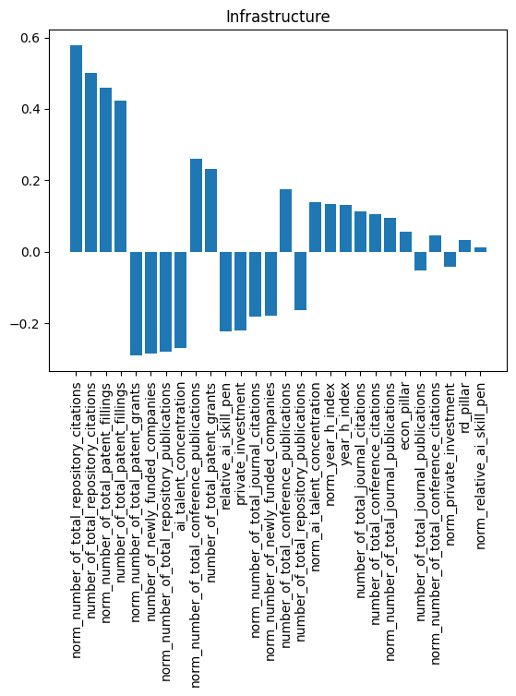

Figure 4 Linear Regression model weights by feature for predicting the Operating Environment AI index score, sorted by absolute value of the coefficient
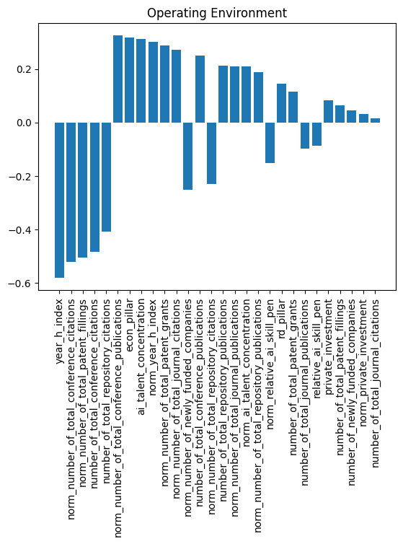

Figure 5 Linear Regression model weights by feature for predicting the Research AI index score, sorted by absolute value of the coefficient
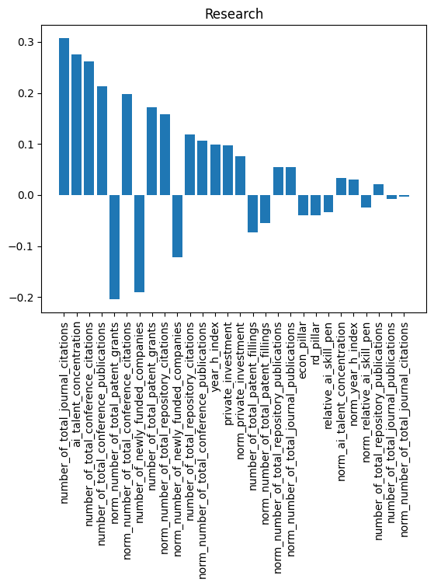

Figure 6 Linear Regression model weights by feature for predicting the Development AI index score, sorted by absolute value of the coefficient
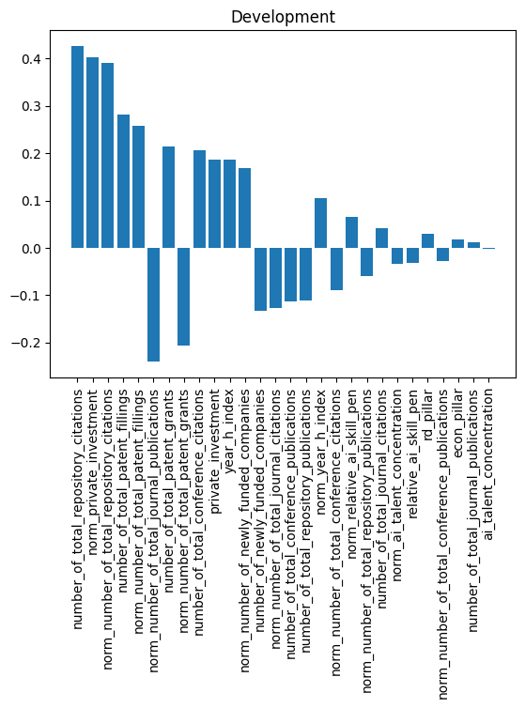

Figure 7 Linear Regression model weights by feature for predicting the Government Strategy AI index score, sorted by absolute value of the coefficient
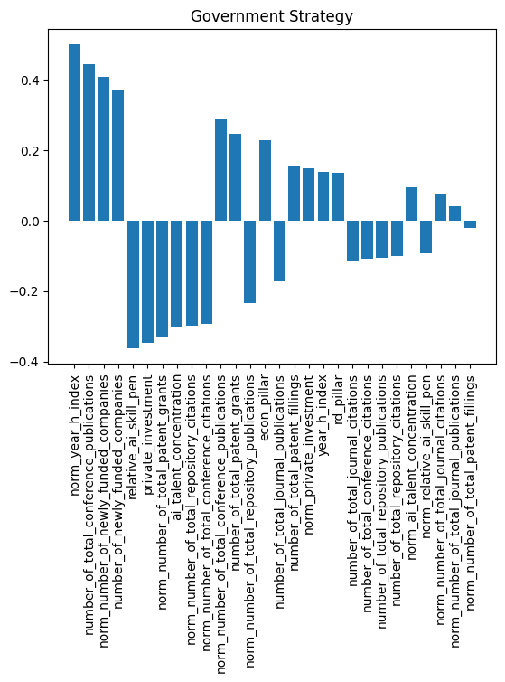

Figure 8 Linear Regression model weights by feature for predicting the Commercial AI index score, sorted by absolute value of the coefficient
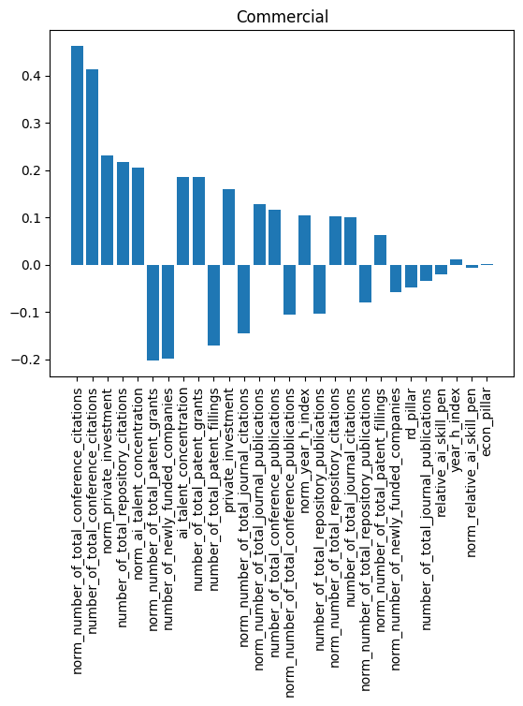

Figure 9 Linear Regression model weights by feature for predicting the Scale AI index score, sorted by absolute value of the coefficient
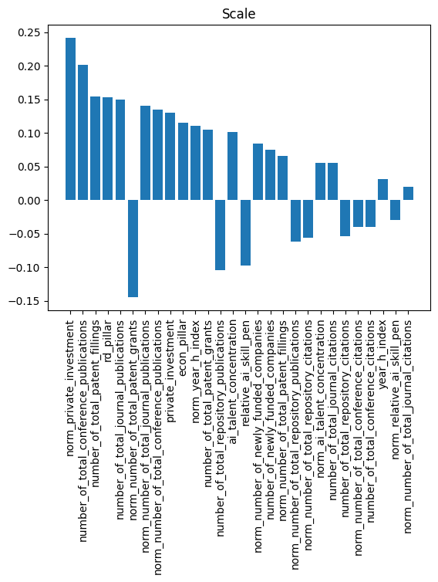

Figure 10 Linear Regression model weights by feature for predicting the Intensity AI index score, sorted by absolute value of the coefficient
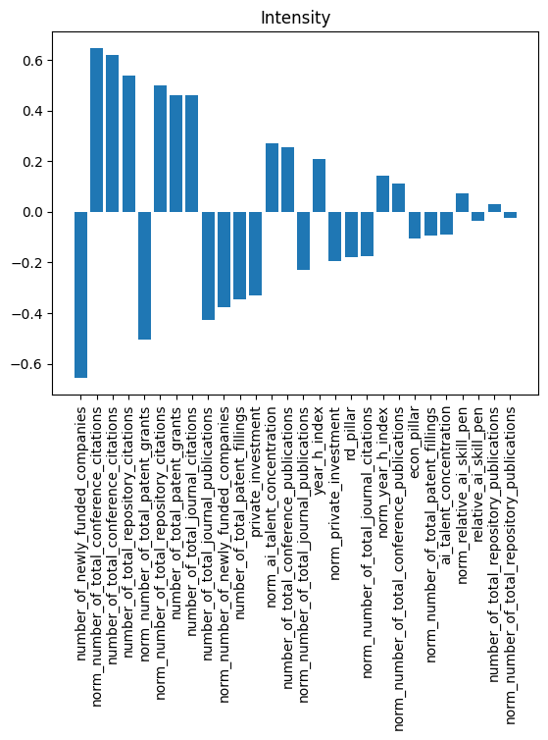

LLM Chatbot Demonstration
The chatbot uses a Retrieval-Augmented Generation (RAG) pipeline to ground all responses in our project’s analyses. Project documents are loaded, converted to text, chunked, and embedded using OpenAI’s text-embedding-3-small model, with embeddings stored in a Chroma vector database for semantic retrieval. For each query, the system retrieves the most relevant text segments and supplies them to a GPT model, ensuring responses reflect our actual project findings. The chatbot is deployed through a Streamlit interface, enabling interactive access while managing API keys securely.

